## Week 4 Homework Submission File: Linux Systems Administration

### Step 1: Ensure/Double Check Permissions on Sensitive Files

1. Permissions on `/etc/shadow` should allow only `root` read and write access.

- Command to inspect permissions: ls -l shadow

- Command to set permissions (if needed): sudo chmod 600 shadow

2. Permissions on `/etc/gshadow` should allow only `root` read and write access.

- Command to inspect permissions: ls -l gshadow

- Command to set permissions (if needed): sudo chmod 600 shadow

3. Permissions on `/etc/group` should allow `root` read and write access, and allow everyone else read access only.

- Command to inspect permissions:ls -l group

- Command to set permissions (if needed)(not needed but included):sudo chmod 644 group

4. Permissions on `/etc/passwd` should allow `root` read and write access, and allow everyone else read access only.

- Command to inspect permissions:ls -l passwd

- Command to set permissions (if needed)(not needed but included):sudo chmod 644 passwd

### Step 2: Create User Accounts

1. Add user accounts for `sam`, `joe`, `amy`, `sara`, and `admin`.

- Command to add each user account (include all five users):

sudo adduser sam

sudo adduser joe

sudo adduser amy

sudo adduser sara

sudo adduser admin

2. Ensure that only the `admin` has general sudo access.

- Command to add `admin` to the `sudo` group:sudo usermod -aG sudo admin

### Step 3: Create User Group and Collaborative Folder

1. Add an `engineers` group to the system.

- Command to add group: sudo groupadd engineers

2. Add users `sam`, `joe`, `amy`, and `sara` to the managed group.

- Command to add users to `engineers` group (include all four users):

sudo usermod -G engineers sam

sudo usermod -G engineers joe

sudo usermod -G engineers amy

sudo usermod -G engineers sara

3. Create a shared folder for this group at `/home/engineers`.

- Command to create the shared folder: sudo mkdir engineers

4. Change ownership on the new engineers' shared folder to the `engineers` group.

- Command to change ownership of engineer's shared folder to engineer group:

sudo chown :engineers /home/engineers

### Step 4: Lynis Auditing

1. Command to install Lynis: sudo apt-get install lynis

2. Command to see documentation and instructions: lynis show commands

3. Command to run an audit: sudo lynis audit system

4. Provide a report from the Lynis output on what can be done to harden the system.

- Screenshot of report output:

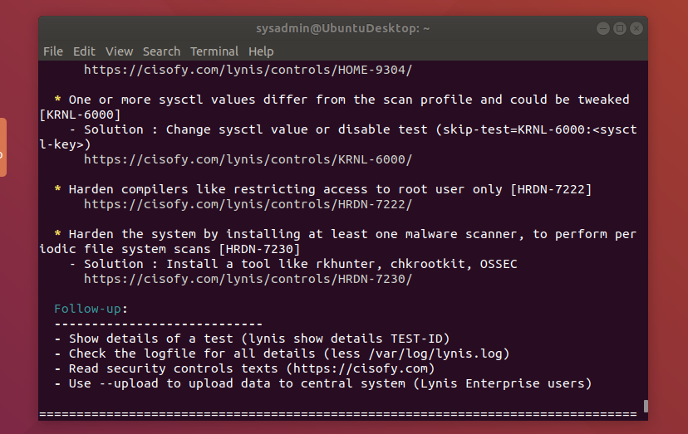

### Bonus

1. Command to install chkrootkit: sudo apt install chkrootkit

2. Command to see documentation and instructions:sudo chkrootkit -h

3. Command to run expert mode:sudo chkrootkit -x

4. Provide a report from the chrootkit output on what can be done to harden the system.

- Screenshot of end of sample output:

---

© 2020 Trilogy Education Services, a 2U, Inc. brand. All Rights Reserved.